GNU Octave, version 3.8.2
Copyright (C) 2014 John W. Eaton and others.
This is free software; see the source code for copying conditions.
There is ABSOLUTELY NO WARRANTY; not even for MERCHANTABILITY or
FITNESS FOR A PARTICULAR PURPOSE. For details, type 'warranty'.

Octave was configured for "x86_64-pc-linux-gnu".

Additional information about Octave is available at http://www.octave.org.

Please contribute if you find this software useful.
For more information, visit http://www.octave.org/get-involved.html

Read http://www.octave.org/bugs.html to learn how to submit bug reports.
For information about changes from previous versions, type 'news'.

a = 1.000000
l = 1.000000
T = 0.200000

ε = 0.000000

n = 10
k = 10
hx = 0.100000
ht = 0.020000

Начальное возмущение =
0.25 * sin(pi * x)

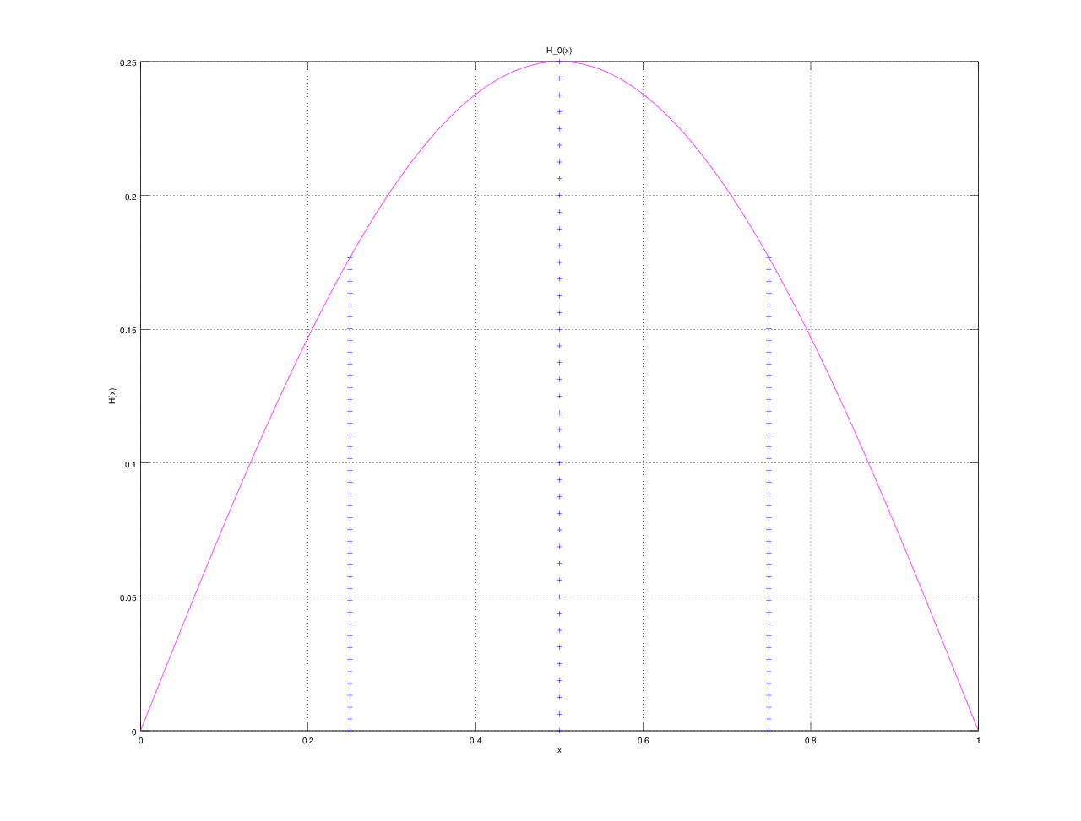

Всего демпферов: 3

Демпфер # 1

x_1 = 0.250000

Верхнее предельное значение w_1(t) =
10

Нижнее предельное значение w_1(t) =
NaN

Управляющая функция w_1(t):
-0.21764
-6.38068
-3.24103
1.30994
2.69420
1.84433
3.02524
2.87454
6.58951
3.49487
2.65850

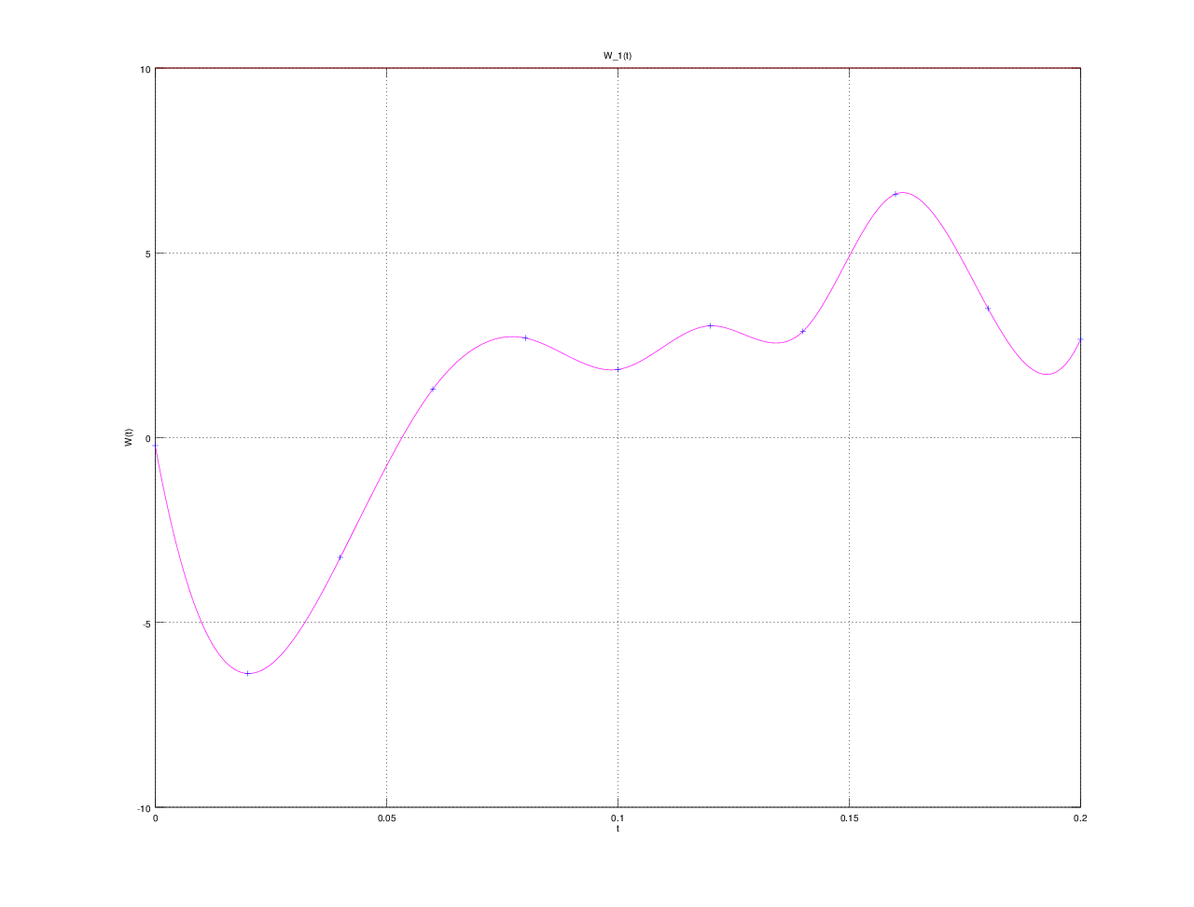

Демпфер # 2

x_2 = 0.500000

Верхнее предельное значение w_2(t) =
10

Нижнее предельное значение w_2(t) =
NaN

Управляющая функция w_2(t):
0.89339
-5.19948
-1.54489
3.54348
6.88172
4.57576
5.32600
5.46527
9.99982
6.07056
0.61674

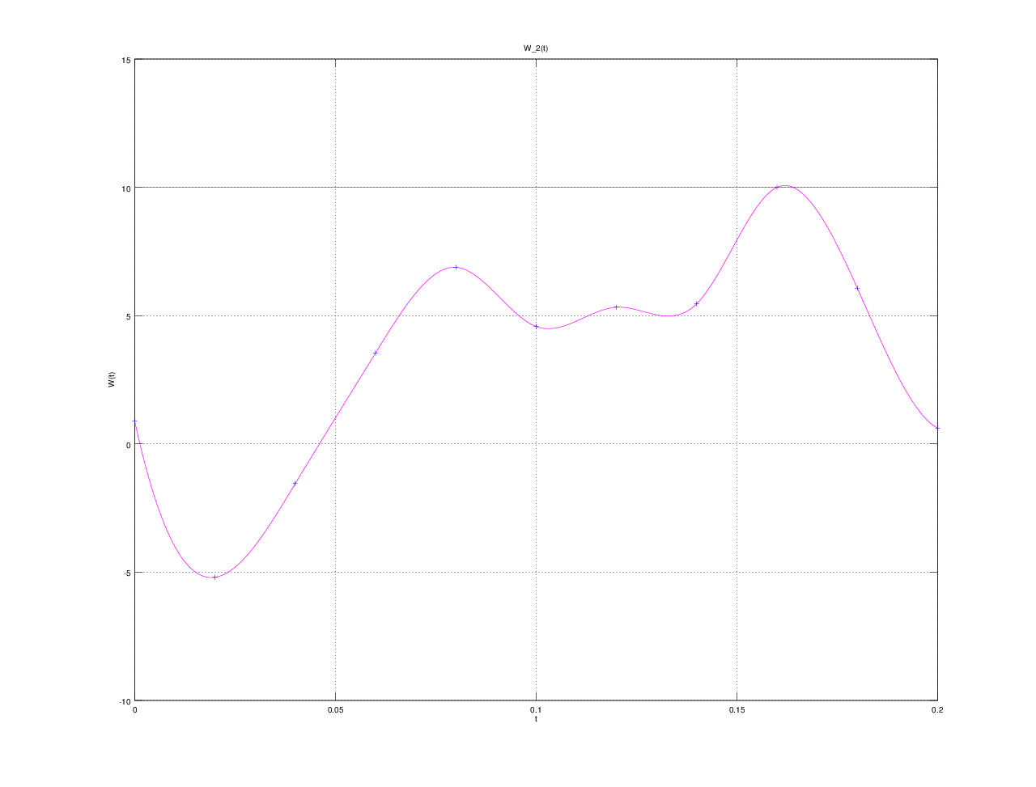

Демпфер # 3

x_3 = 0.750000

Верхнее предельное значение w_3(t) =
10

Нижнее предельное значение w_3(t) =
NaN

Управляющая функция w_3(t):
-0.22399
-6.36471
-3.23770
1.30601
2.70044
1.84499
3.02985
2.87437
6.59428
3.49199
2.64753

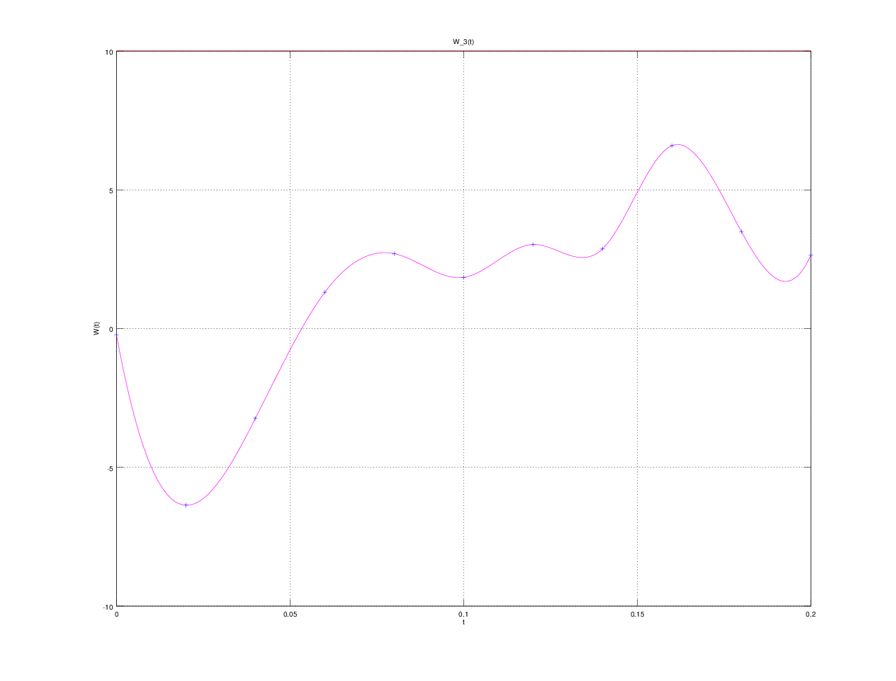

E(T) =
1.3045e-08

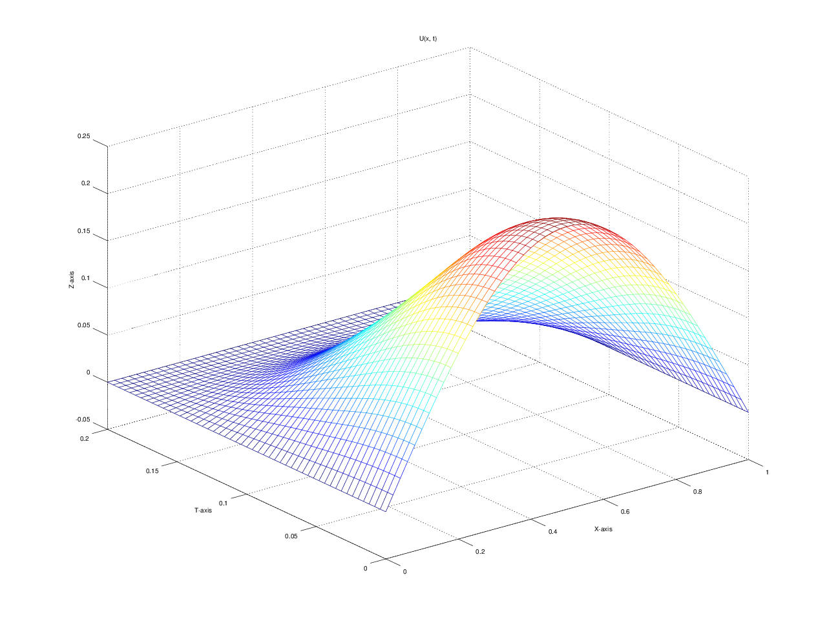

u(x, t)
T = 0.000000: 0.000000 0.077254 0.146946 0.202254 0.237764 0.250000 0.237764 0.202254 0.146946 0.077254 0.000000
T = 0.020000: 0.000000 0.074768 0.142024 0.195999 0.231142 0.242920 0.231143 0.196002 0.142027 0.074770 0.000000
T = 0.040000: 0.000000 0.066893 0.127549 0.176887 0.209430 0.220475 0.209438 0.176900 0.127562 0.066901 0.000000
T = 0.060000: 0.000000 0.055704 0.106826 0.148034 0.175049 0.184992 0.175064 0.148057 0.106849 0.055719 0.000000
T = 0.080000: 0.000000 0.044332 0.084290 0.116018 0.136808 0.144579 0.136822 0.116039 0.084311 0.044345 0.000000
T = 0.100000: 0.000000 0.032444 0.061748 0.084993 0.100198 0.106007 0.100205 0.085005 0.061759 0.032451 0.000000
T = 0.120000: 0.000000 0.020733 0.040234 0.056128 0.066698 0.070894 0.066699 0.056127 0.040234 0.020733 0.000000
T = 0.140000: 0.000000 0.011284 0.021841 0.030743 0.037075 0.039869 0.037069 0.030734 0.021832 0.011278 0.000000
T = 0.160000: 0.000000 0.004516 0.008978 0.012192 0.014437 0.016276 0.014430 0.012182 0.008968 0.004510 0.000000
T = 0.180000: 0.000000 0.000960 0.002027 0.002575 0.002886 0.003559 0.002884 0.002571 0.002023 0.000957 0.000000
T = 0.200000: 0.000000 -0.000006 -0.000011 0.000006 -0.000018 0.000006 -0.000018 0.000006 -0.000011 -0.000006 0.000000

